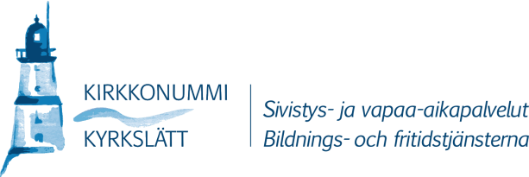
1 (1)

Simplified version for the guardians

Principles of the afternoon activities for pupils in Kirkkonummi
- Pupils in the first and the second form and pupils receiving special support in all forms can apply to the afternoon club.
- The afternoon club is after school on school days.
- The afternoon club is open from 12 to 17.
- In the afternoon club we play and eat snacks.
- It costs money to participate in the afternoon club. You can apply for a reduced fee.
- There is no transport from the afternoon club.

Applying to the afternoon club

- Fill in an application for the afternoon activity.
- The child can get a place in the afternoon club if there are places available. The spot is valid during the whole school year.
- The child can participate in the afternoon club after school every day (“full week activity”) or three days a week (“part time activity”).
  - Five days a week cost 155 euros per month.
  - Three days a week cost 100 euros per month.

Reduction of the fee

- You can get a reduction of the fee if you have a small income. Fill in the “form for reduced monthly fee”. Attach your income information. Apply for the reduction by the end of the month for which you want the reduction. The form is available at: www.kirkkonummi.fi/koululaisten-iltapaivatoiminta

Change of participation

- If you want the child to quit the afternoon club, fill in the form for “change of afternoon activity”.
Fill in the form on the 15 th of the month at the latest if you want your child to quit the afternoon club at the end of the month. The form is available at: www.kirkkonummi.fi/koululaisten-iltapaivatoiminta

- You can change a full week to a partial week and vice versa. Fill in the form “change of afternoon activity”.

More information: www.kirkkonummi.fi/koululaisten-iltapaivatoiminta

Address | Street address | Telephone | Fax
Municipality of Kirkkonummi | Ervastintie 2 | 09 296 71 | 09 878 6053
PO Box 20  02401 Kirkkonummi | Kirkkonummi  02400 Kirkkonummi | kirjaamo@kirkkonummi.fi | www.kirkkonummi.fi

